Richards stuff

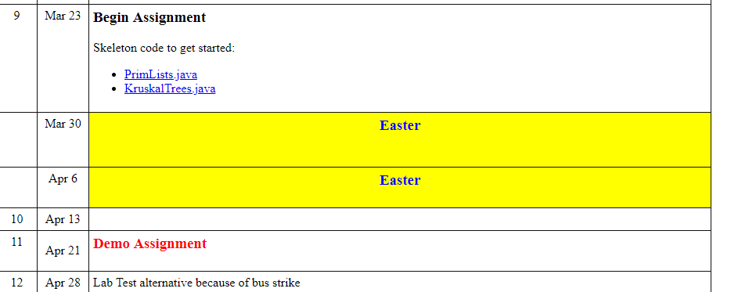

<http://www.comp.dit.ie/rlawlor/Alg_DS/labs.html>

Original Criteria:

Using the provided skeleton code, complete the assignment using the MST algorithm Kruskal and Prim. More instructions are in the code itself. After completing the assignment, you are required to demo the assignment on the 20th April 2018 (Week 11 lab time). You may use the provided text file such as WGraph3.txt .